Exp. 3. Simulation of Energy States of Quantum Dot using NanoHub
Aim: To obtain the energy states of Quantum dots.
Case Study 1: Simulate the energy states of cylindrical quantum dots of X=15 nm, Y=10.5nmand Z = 8 nm
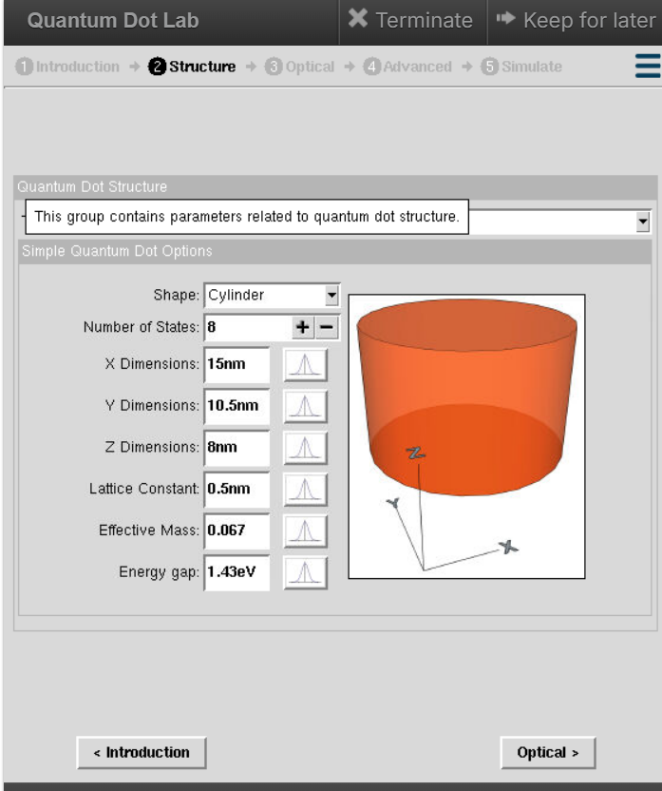
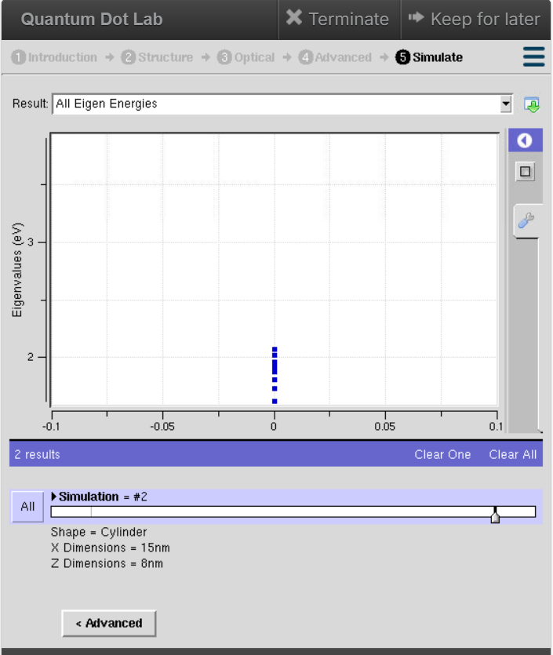

Case Study 2: Simulate the energy states of two layer cuboid quantum dots
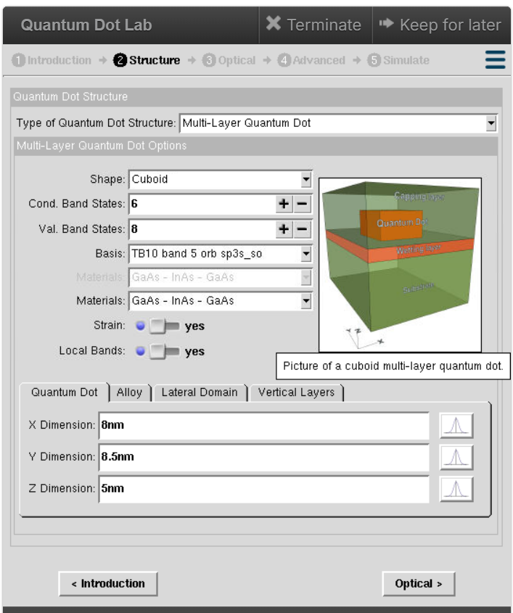
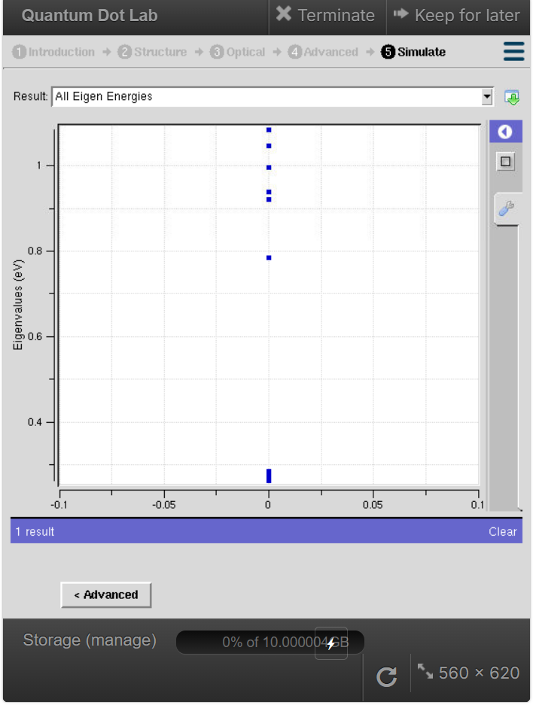

Result:
The Simulation of energy states of quantum dots is accomplished.

